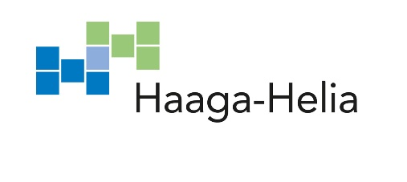
WORK PLACEMENT CONTRACT

By this contract the employer and the employee agree that the student of the Haaga-Helia University of Applied Sciences mentioned below may do the practical training as part of her/his studies in the employer’s organisation. In order to enable the student to write the required report, the employer agrees to give her/him the information necessary for this purpose. The employer is entitled to have a copy of the report. It is also desirable that the employer evaluate the student’s job performance and advice her/him on how to develop her/himself. The work placement advisor appointed by Haaga-Helia may also contact the employer. The work placement is full-time training at the location indicated by the employer.

Employer

Postal address of trainee’s job location
Contact person  in matters concerning the work placement | Name and position |  | Telephone
 | E-mail |  | Fax
Fee | ❒Paid work placement | ❒Unpaid work placement
Trainee | Name |  | Student code
 | E-mail |  | Telephone
 | Home address Postal code City or town
Description of duties

Duration and dates of the work placement | Duration Commencement day Final date
Date

Employer’s signature
Trainee’s signature

